Dear Visitor to the Hubbard County Region,
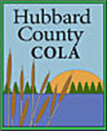
[Your logo here]

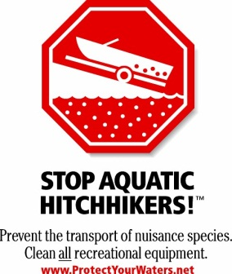
Aquatic Invasive Species Information for Our Guests
All boats launch (at a public watercraft access close to resort). Boat Inspections take place there.

Thank you for bringing a dry/clean boat to keep our lake free of invasive species. Be sure to travel with your plug out and do not put in till you arrive at the access.
Please be ready to answer a few questions for us when you arrive. When was the last time your boat was in the water? If it was less than two weeks...what lake was your boat in?
Hubbard County has a watercraft decontamination station available for you if your watercraft arrives from infested waters with invasive visually present, your watercraft was in infested waters more than 24 hours, and your watercraft has been out of the infested water less than 5 days.
Note all watercraft and watercraft equipment can spread invasive species...this not only includes motor boats but sail boats, kayaks, fishing gear, and waders.
Remember you must...
CLEAN all visible aquatic plants, zebra mussels and other prohibited invasive species from watercraft, trailers, and water-related equipment before leaving any water access or shoreland.
DRAIN WATER-RELATED EQUIPMENT (boat, ballast tanks, portable bait container, motor} and drain bilge, livewell, and bait well by removing drain plugs before leaving a water access or shoreland property. Keep drain plugs out and water-draining devices open while transporting watercraft.
DISPOSE of unwanted bait, including minnows, leeches, and worms, in the trash. It is illegal to release live bait into a waterbody or release aquatic animals from one waterbody to another. If you want to keep your live bait, you must refill the bait container with bottled or tap water.

For more information, visit www.mndnr.gov/invasives.

We look forward to your visit.
(Insert Resort or Business Owner/Manager Name)

